MUSIC P2

FEBRUARY/MARCH 2018

MARKING GUIDELINES

NATIONAL

SENIOR CERTIFICATE

GRADE 12

MARKS: 30

These marking guidelines consist of 17 pages.

INSTRUCTIONS AND INFORMATION

1.  2.  3.  4.  5.  6.  7.  8.  9.  10. | This question paper consists of THREE sections:  SECTION A: Aural (10)  SECTION B: Recognition (12)  SECTION C: Form (8)  QUESTION 1, QUESTION 2, QUESTION 3 and QUESTION 7 are COMPULSORY.  Answer QUESTION 4 (Western Art Music (WAM)) OR QUESTION 5 (JAZZ) OR QUESTION 6 (Indigenous African Music (IAM)).  Write all your answers on this question paper. Use a pencil for music notation and blue or black ink for the other answers.  This examination will be done while candidates are listening to a CD.  The music teacher of the centre must conduct the examination in the presence of the invigilator.  The last page of this question paper is manuscript paper intended for rough work. The candidate MUST NOT remove this page.  Candidates may NOT have access to any musical instrument for the duration of this examination.  Candidates must take note of the mark allocation of each question in order to provide enough information in their answer.  Write neatly and legibly.

INSTRUCTIONS TO THE PERSON OPERATING THE SOUND EQUIPMENT

1.  2.  3.  4.  5.  6.  7. | The instructions for the music teacher appear in frames.  Each music extract (track) must be played the number of times specified in the question paper.  Allow adequate time between tracks to give candidates time to think and write their answers before playing the next track.  The number of the track must be announced clearly each time before it is played.  If a school offers more than one stream (Western Art Music (WAM)), jazz, Indigenous African Music (IAM)), the following guidelines must be followed:  - Each stream must do the examination in a separate venue.  - Each venue must be equipped with suitable sound equipment.  - Each venue must have its own CD with music extracts.  - An invigilator must be present in each venue.  The tracks have to be played as follows:  - WAM candidates: Tracks 1–24 and Track 37–39  - JAZZ candidates: Tracks 1–12, Tracks 25–30 and Track 37–39  - IAM candidates: Tracks 1–12 and Tracks 31–39  A battery-powered CD player must be available in case of a power failure.

SUMMARY OF MARKS

SECTION A: AURAL | TOTAL
QUESTION 1 (COMPULSORY) | 5
QUESTION 2 (COMPULSORY) | 5
SUBTOTAL | 10

SECTION B: RECOGNITION | TOTAL
QUESTION 3 (COMPULSORY) | 4
QUESTION 4 (WAM) OR | 8
QUESTION 5 (JAZZ) OR | 8
QUESTION 6 (IAM) | 8
SUBTOTAL | 12

SECTION C: FORM | TOTAL
QUESTION 7 (COMPULSORY) | 8
SUBTOTAL | 8

GRAND TOTAL | 30

Note to marker: Candidates must be credited for any correct answers not given in the memorandum.

SECTION A: AURAL

QUESTION 1

Play Track 1 TWICE in succession.

1.1 | Listen to the melodic and rhythmic phrase. Notate the rhythm of the missing notes in bars 2–3 below.

Play Track 1 TWICE again. Pause for 30 seconds in between.

 | Answer:  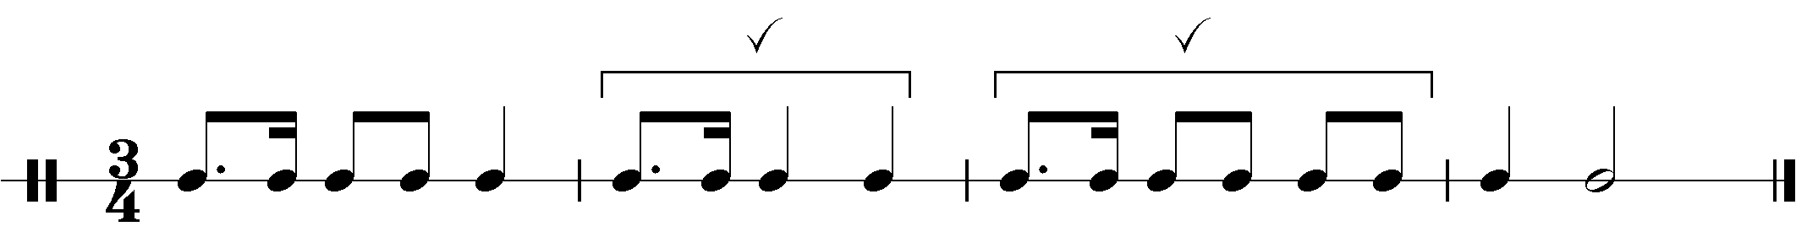  1 mark per bar = 2 marks  Minus ½ mark per mistake up to a maximum of 1 mark per bar | (2)

Play Track 2 THREE times in succession.

1.2 | Listen to the extract from the Chorale Ein' feste Burg by JS Bach. Which ONE of the melodies (a), (b) or (c) corresponds with the music that you hear? Make a cross (X) in the appropriate block.

(a)
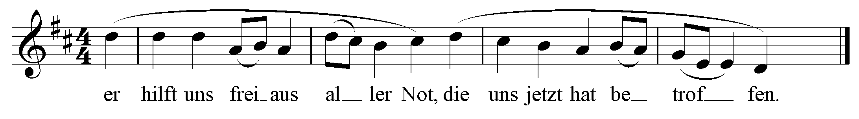

(b)
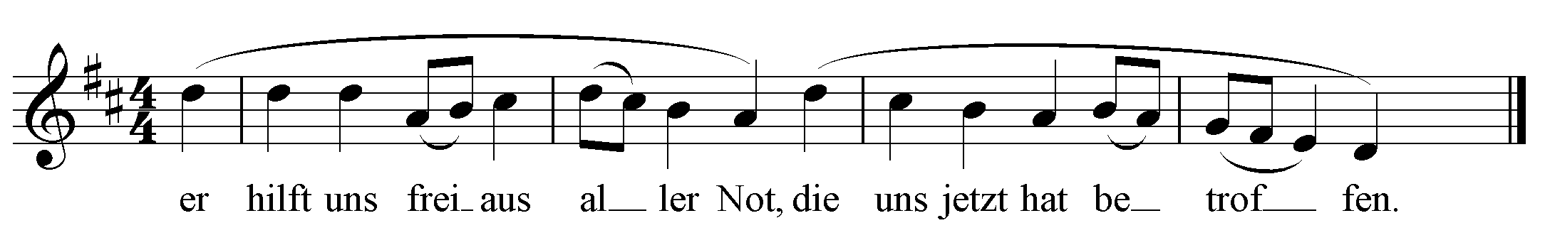
X

(c)
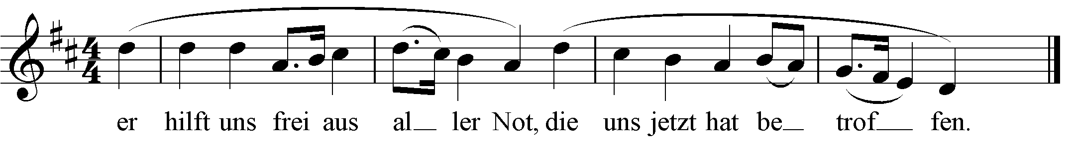

Correct answer = 1 mark |  |  | (1)

Play Track 3 ONCE.

1.3 | With which of the textures below do you associate this extract? Make a cross (X) in TWO appropriate blocks.
 | Answer: Monophony AND Homophony TWO correct answers = 2 marks |  |  | (2)
 |  |  |  |  | [5]

QUESTION 2

Play Track 4 ONCE to provide a general overview.

Listen to the extract from Minuetto Scherzando by A Scarlatti and answer the questions that follow.

Answer:
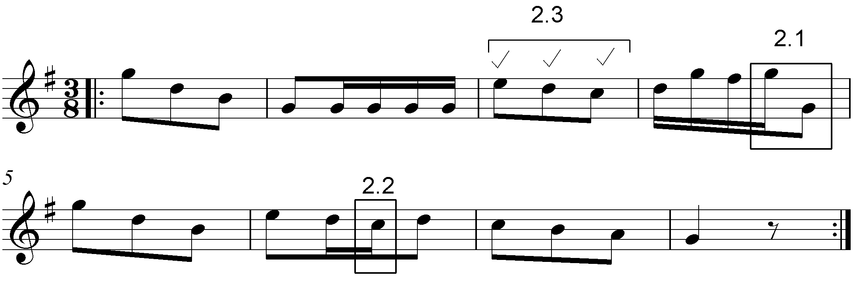

Play Track 5 TWICE.

2.1 | Listen to bars 1–4. Name the interval formed between G and the missing note at 2.1, for example major 3rd.

 | Answer: (Perfect) Octave = 1 mark |  | (1)

Play Track 6 TWICE.

2.2 | Listen to bars 5–8. Name the non-chordal note formed at 2.2, for example passing note.

 | Answer: (Lower) Auxiliary note = 1 mark |  | (1)

Play Track 7 THREE times.

2.3 | The notation of bar 3 has been omitted on the score at 2.3. Fill in the missing pitches and note values that correspond with the music that you hear.

 | Answer: See score: Correct pitch and note value = 1 mark each = 3 marks No mark for correct pitch or note value only | (3)

 |  |  | [5]
 | TOTAL SECTION A: |  | 10

SECTION B: RECOGNITION OF MUSIC CONCEPTS

QUESTION 3: GENERAL LISTENING (COMPULSORY)
Study the items in COLUMN A in QUESTIONS 3.1–3.3 for two minutes.
Note to marker: If a candidate selected more than two items at a question, only the first two items must be marked.

Play Track 8 TWICE.

3.1 | Indicate TWO items in COLUMN A that relate to the music that you hear.  Make a cross (X) in TWO appropriate blocks.
Answer:
COLUMN A | Track 8
Female voices only
Change of key | X
A Cappella | X
Minor
Repetition | X
Instrumental

 | Any TWO correct answers = 2 marks |  | (2)

Play Track 9 TWICE.

3.2 | Indicate TWO items in COLUMN A that relate to the music that you hear.  Make a cross (X) in TWO appropriate blocks.
Answer:
COLUMN A | Track 9
A Cappella
Change of key
Marimba | X
Trombone
Saxophone | X
Idiophones | X

 | Any TWO correct answers = 2 marks |  | (2)

Play Track 10 TWICE.

3.3 | Indicate TWO items in COLUMN A that relate to the music that you hear.  Make a cross (X) in TWO appropriate blocks.
Answer:
COLUMN A | Track 10
Major | X
Triple time
Ostinato | X
Quadruple time | X
Adagio
Minor

 | Any TWO correct answers = 2 marks |  | (2)

3.4 | Listen to the following TWO extracts and answer the questions that follow.

Play Tracks 11 ONCE.

 | 3.4.1 | With which ONE of the following do you associate this extract?  Make a cross (X) in the appropriate block.

 |  | Answer: Waltz = 1 mark |  | (1)

Play Tracks 12 ONCE.

 | 3.4.2 | With which ONE of the following do you associate this extract?  Make a cross (X) in the appropriate block.

 |  | Answer: Harp = 1 mark |  | (1)

 | (8 ÷ 2) |  | [4]

Answer QUESTION 4 (WAM) OR QUESTION 5 (JAZZ) OR QUESTION 6 (IAM).

QUESTION 4: WAM

4.1 | Listen to the extracts from The Magic Flute by Mozart and answer the questions that follow.

Play Track 13, Track 14 and Track 15 ONCE each.

 | 4.1.1 | Identify the most suitable term to describe the character of the extracts. Choose from the list below. Make a cross (X) in the appropriate block.
 |  | Answer:  Term Track 13 Track 14 Track 15  Lustig X  Semplice  Subito  Con fuoco X  Allegretto  Grave X  One mark per extract x 3 = 3 marks |  | (3)

Play Track 16 ONCE.

 | 4.1.2 | Name the character that sings in this extract.  Answer: Tamino = 1 mark |  | (1)

 | 4.1.3 | Name the voice type of this character.  Answer: Tenor = 1 mark |  | (1)

4.2 | Listen to the extracts and answer the questions that follow.

Play Track 17 ONCE.

 | 4.2.1 | Identify the genre/work type of this extract, for example Concerto.  Answer: Symphony = 1 mark |  | (1)

 | 4.2.2 | Identify the composer of this extract.  Answer: Beethoven = 1 mark |  | (1)

 | 4.2.3 | What is the tonality of this extract?  Answer: Minor = 1 mark |  | (1)

Play Track 18 ONCE.

 | 4.2.4 | Identify the statement in COLUMN A that relates to the music that you hear. Make a cross (X) in the appropriate block.  Answer:  COLUMN A  The double basses and cellos play a pedal point  The double basses and cellos play tremolo X  The violas and double basses play pizzicato  The violas and cellos play an ostinato  Correct answer = 1 mark |  | (1)

Play Track 19, Track 20 and Track 21 ONCE each.

 | 4.2.5 | Identify the woodwind instrument in each extract. Write the answer in the table below.

 |  | Answer:  Track 19 Flute  Track 20 Oboe  Track 21 Clarinet  One mark per correct instrument x 3 = 3 marks |  | (3)

Play Track 19, Track 20 and Track 21 ONCE more.

4.3 | Listen to the extracts and answer the questions that follow.

Play Track 22 ONCE.

 | 4.3.1 | Name TWO compositional techniques used in this extract?  Answer: Repetition Variation on the theme Melodic material in the bass part Accompanied in the higher instruments Any TWO correct answers = 2 marks |  | (2)

Play Track 23 and 24 TWICE in succession.

 | 4.3.2 | Compare the melodies in the following two extracts and state one similarity and one difference.
 |  | Answer:  Similarities - Melody line - Rhythmic pattern - Dynamics - mostly piano - cresc/decresc - Articulation - legato  Differences - Instrumentation - Track 23 played by cellos/low strings - Track 24 played by violins/high strings - Pitch - The second melody (an octave) higher  Any ONE correct similarity and difference = 2 marks |  | (2)

 | (16 ÷ 2) | [8]

 | TOTAL SECTION B: | 12
OR

QUESTION 5: JAZZ

5.1 | Listen to the extract and answer the questions that follow.

Play Track 25 ONCE.

 | 5.1.1 | Identify the South African jazz style that you hear in this extract.
 |  | Answer: Marabi = 1 mark |  | (1)

 | 5.1.2 | Give TWO reasons, related to the music, to motivate your answer to QUESTION 5.1.1.
 |  | Answer: - Continuous repetition of music material above a rhythmic ostinato (riff) - Cyclic harmonic progression - Mixture of Western instrumentation (drum kit, bass and electric guitar, keyboard) and South African vocal style - Jazz influence heard in the guitar and bass Any TWO correct answers = 2 marks |  | (2)

 | 5.2.3 | Name ONE artist/band that you associate with this extract.
 |  | Answer: - The Flying Jazz Queens - The Dark City Sisters - Mahotella Queens Any 1 correct answer = 1 mark |  | (1)

5.2 | Listen to the extracts and answer the questions that follow.

Play Track 26 ONCE.

 | 5.2.1 | Identify the South African jazz style that you hear in this extract.

 |  | Answer: - Cape jazz - Modern jazz - Afro jazz Any correct answer = 1 mark |  | (1)

 | 5.2.2 | Name an artist that you associate with your answer to QUESTION 5.2.1.
 |  | Answer: Winston Mankunku = 1 mark |  | (1)

 | 5.2.3 | Name the compositional technique used in the piano part.
 |  | Answer: Ostinato/Riff = 1 mark |  | (1)

 | 5.2.4 | Name ONE idiophone that you hear in this extract.
 |  | Answer: Cymbals/Hi-hat = 1 mark |  | (1)

Play Track 27 ONCE.

 | 5.2.5 | Describe the use of rhythm that you hear in the piano part.
 |  | Answer: - Rhythmic motive in right hand of the piano is repeated throughout the track - Rhythmic material is syncopated TWO correct answers = 2 marks |  | (2)

5.3 | Listen to the extract and answer the questions that follow.

Play Track 28 TWICE.

 | 5.3.1 | Name an artist that you associate with this extract.
 |  | Answer: - Philip Tabane - Abbey Cindi - Julian Bahula Any ONE correct answer = 1 mark |  | (1)

 | 5.3.2 | Describe the music style you hear in this extract by referring to THREE musical features.
 |  | Answer: - Modern instrumentation combined with traditional instrumentation (African drums, shakers, bass guitar, electric lead guitar) - Use of African horn - Percussive and ritualistic use of shakers - Blues tonal vocal melodic pattern - Blues bending of notes on guitar - Jazz based harmonies Any THREE correct answers = 3 marks |  | (3)

Play Track 29 and Track 30 TWICE in succession

5.4 |  | Listen to the following TWO extracts and identify TWO differences with regards to the beat and instruments that drive the rhythm.
 | Answer:  Feature Track 29 Track 30  Beat Ghoema beat Typical Cape Malay beat Skiffle-like beat  Instruments Piano/drums/bass Penny whistle/ Guitar/banjo/drums  Any two corresponding correct answers x2 = 4 marks |  |  |  |  |  | (4)
 |  |  |  | (16 ÷ 2) |  |  |  | [8]
 |  |  |  | TOTAL SECTION B: |  |  |  | 12

OR

QUESTION 6: IAM

6.1 | Listen to the extracts and answer the questions that follow.

Play Track 31 ONCE.

 | 6.1.1 | Identify the South African style of music heard in this extract.
 |  | Answer: Isicathamiya = 1 mark |  | (1)

 | 6.1.2 | Give THREE reasons, related to the music, to motivate your answer to QUESTION 6.1.1.
 |  | Answer: - Choral-style singing - TTBB - Lyrics in isiZulu - A cappella - Vocal techniques e.g. crepitations - Repetition Any THREE correct answers = 3 marks |  | (3)

Play Track 32 ONCE.

 | 6.1.3 | Give TWO features that make this extract different from the original style mentioned in QUESTION 6.1.1.
 |  | Answer: - Female singers/Treble voices - English lyrics instead of Isizulu - The female takes the lead in the call and response Any TWO correct answers = 2 marks |  | (2)

 | 6.1.4 | Name an artist associated with this extract.
 |  | Answer: Ladysmith Black Mambazo = 1 mark |  | (1)

6.2 | Listen to the extract and answer the questions that follow.

Play Track 33 ONCE.

 | 6.2.1 | Describe the use of rhythm between the clapping and the drums.

 |  | Answer: - Clapping - straight crotchet beat - accents on different beats (on one and four or three and one) - repetition - Drums - dotted quaver rhythms following the rhythm of the feet movement of the dance - repetition - resulting in cross rhythms Any TWO correct answers = 2 marks |  | (2)

 | 6.2.2 | Identify the idiophone that you hear.

 |  | Answer: Cow bell = 1 mark |  | (1)

Play Tracks 34 and 35 TWICE in succession.

6.3 | Identify TWO differences in the extracts that you hear with regard to the relevant style and the use of drums.
 | Answer:  Criteria Track 34 Track 35  Style Maskandi Traditional Basotho style (Famo)  Drums Drumkit: To keep the beat and to give a contemporary sound Traditional, home-made drums: To keep the beat and create polyrhythm  Any TWO corresponding correct answers x 2 = 4 marks |  | (4)

6.4 | Listen to the extract and answer the questions that follow.

Play Track 36 ONCE.

 | 6.4.1 | Identify the South African music style that you hear in this extract.
 |  | Answer: Malombo = 1 mark |  | (1)

 | 6.4.2 | Name an artist/band that you associate with this extract.
 |  | Answer: - Philip Tabane - Malombo - Abbey Cindi - Julian Bahula - Malombo Jazzmen - Malombo Jazz Makers Any correct answer = 1 mark |  | (1)

 |  | (16 ÷ 2) | [8]

 |  | TOTAL SECTION B: | 12

SECTION C: FORM
QUESTION 7

Read and study the questions for ONE minute.

Play Track 37 ONCE to provide an overview.

Listen to the extract from Minuet in G by Beethoven while you study the score.

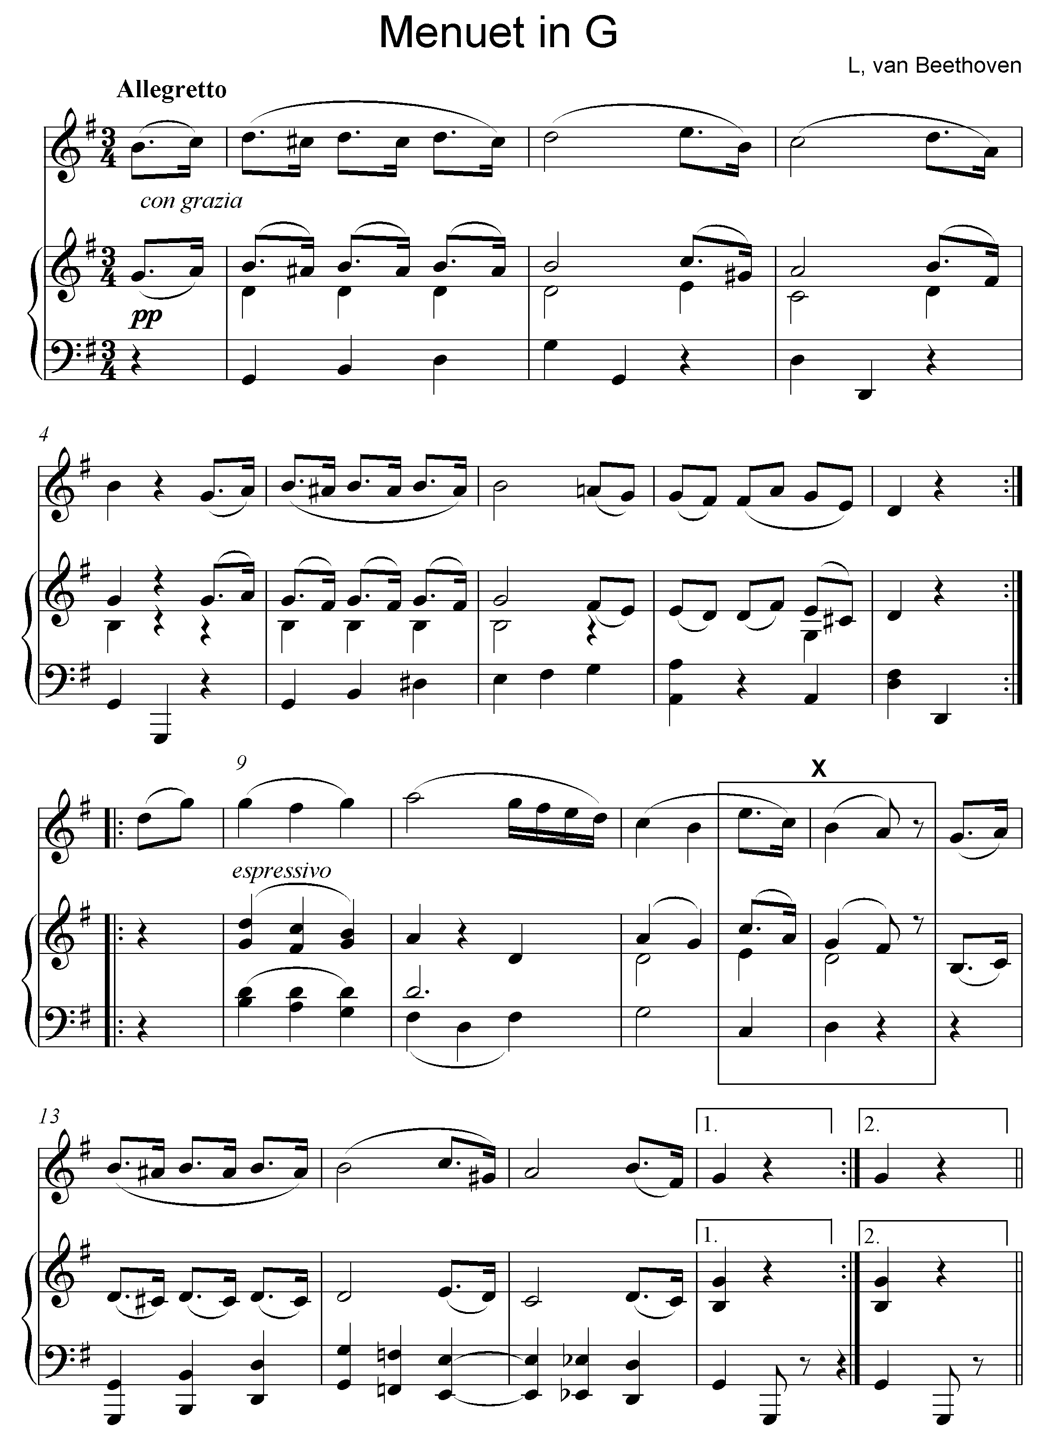

Play Track 37 again.

7.1 | Name the main key of this work.
 | Answer: G Major = 1 mark |  | (1)

7.2 | What is the form of this piece?
 | Answer: - Rounded Binary form (AA :II BA:II) - Binary form (AB) Any correct answer = 1 mark |  | (1)

7.3 | Motivate your answer to QUESTION 7.2 by giving a schematic layout of the form of this piece. Use the table below.

 | Answer:  Rounded Binary  Section Bar numbers  A = ½ 0³–8² = ½  B a = ½ 8³–12² 12³–16² = ½  ½ mark for Section A = 1 mark  ½ mark for correct bar numbers in Section A  ½ mark for correct divisions in Section Ba = 1 mark  ½ mark for correct bar numbers in Section Ba  Binary  Section Bar numbers  A = ½ 0³–8² = ½  B = ½ 8³–16² = ½  ½ mark for each correct section = 1 mark  ½ mark for each correct bar number = 1 mark  Note to marker:  If the bar numbers and the section letters do not correspond ½ mark will be awarded for the section and no mark will be awarded for the bar numbers. |  | (2)

7.4 | To which key does the piece modulate in bars 7–8?
 | Answer: D major = 1 mark |  | (1)

7.5 | What is the function of the A# note in bar 5?
 | Answer: - (Chromatic) auxiliary note - Decoration - A chromatic note to provide colour Any correct answer = 1 mark |  | (1)

Play Track 38 again.

7.6 | Name the cadence formed at X.
 | Answer: Imperfect cadence = 1 mark |  | (1)

7.7 | Give the meaning of allegretto.
 | Answer: Fairly lively and jolly = 1 mark |  | (1)

Play Track 39 for an overview. |  | [8]

TOTAL SECTION C: |  | 8
GRAND TOTAL: |  | 30

