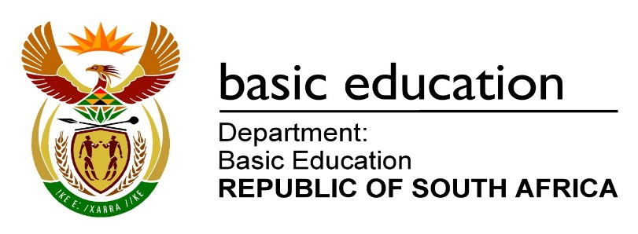

STATEMENT DELIVERED BY THE DEPUTY MINISTER OF BASIC EDUCATION, DR REGINAH MHAULE, MP AT THE MEDIA BRIEFING ON THE BASIC EDUCATION SECTOR PLANS FOR THE OPENING OF SCHOOLS FOR ACADEMIC YEAR 2021

15 January 2021

Good morning ladies and gentlemen. Thank you for attending!
On behalf of Minister Motshekga, who is still on sick leave and recovering well at home, we present this statement.

This briefing comes at a critical time in the country. Normally at this time of the year, schools are reopened; and work resumes with various sectors welcoming their staff. You will recall that the original pre-COVID-19 school calendar had scheduled schools to return on 13 January 2021. Due to the coronavirus last year, we were forced to revise the school calendar for 2020, which automatically affected the 2021 school calendar. We revised the 2021 school calendar; and moved the dates from 13 January to 25 January 2021 for teachers; and the 27 January 2021 for learners.

The coronavirus has turned our lives upside down; and decision-making for a sector as large as basic education, has become a difficult exercise.

The COVID-19 infection rate has increased, and more people are getting infected by the virus. We are seeing more deaths to the extent that almost everybody knows somebody who has been affected by it. In some instances, COVID-19 has wiped out entirely families. It has left massive devastation in its wake, and for many people, their circumstances have changed for the worse forever.

On Monday, 11 January 2021, President Ramaphosa addressed the nation, and said that there was understandable concern about whether it was advisable to reopen schools in the midst of a second wave of infections.

The President said the matter of education was being dealt with by the National Coronavirus Command Council.
Between Tuesday and Wednesday (12 and 13 January 2021), we consulted the Council of Education Ministers (CEM), the Heads of Education Departments Committee (HEDCOM), the national school governing body associations, teacher unions, learner formations, principal associations, as well as the national associations representing independent schools and learners with special education needs. All stakeholders were united in supporting a delay in the opening of schools.

Given the pressure experienced by the health system in the past few weeks, occasioned by increased COVID - 19 infections which has led to the second wave, the Council of Education Ministers in conjunction with the National Coronavirus Command Council and Cabinet, has taken the decision to delay the reopening of both public and private schools with two weeks. This includes private schools that have reopened already. They will need to postpone their reopening to a later date. This is done to provide relief to the health system which is already struggling to cope with the current demands. The new dates for the reopening of private schools will vary depending on the calendar that they follow. For public schools and private schools which follow the same calendar, changes are as follows:

- School Management Teams (SMTs) shall report for duty on Monday, 25 January 2021;
- Teachers shall follow on Monday, 01 February 2021; and
- Lastly, learners return on Monday, 15 February 2021.

The SMTs will go first to prepare for the return of teachers; and the teachers will prepare for the return of learners. Schools will use the time to finalise outstanding matters, regarding admissions, especially the unplaced learners in certain cases.

CEM took this difficult decision, having considered all factors as backed up by research and statistics, regarding the current state of the health system. The priority remains saving lives.

The DBE will work closely with all nine Provincial Education Departments, to establish the true extent of the impact of the virus, resulting from the unfortunate demise of educators, workers and leaders in the sector, especially during the December / January holidays.

As our President correctly mentioned on Monday, funerals remain our biggest albatross in terms of the spread of the virus. The basic education sector, has also felt the impact of COVID-19 pandemic during the marking of the 2020 National Senior Certificate (NSC) examination scripts.

Some of our markers have passed away; while others withdrew from marking, due to fear and anxiety; but also because for some of them, their own family members have tested positive. In the majority of cases, the educators indicated they had attended funerals or ceremonies, attended by big groups of people; resulting in gatherings that were not monitored for compliance with health protocols, which includes the wearing of masks, social distancing, and regular sanitising of hands.

We will have a series of meetings with provinces next week, to check on the very latest, regarding the state of readiness; taking into account the Cabinet decision from yesterday’s meeting.

Now that Cabinet has taken a decision, we will once again go back to our stakeholders for consultation on the details of the opening of schools for 2021 school year, amid the pandemic.

Let me take this opportunity to thank the Minister, MECs, HoDs of PEDs, our social partners and stakeholders, as well as all colleagues in the sector for the work done thus far. We are living under difficult circumstances that require commitment, dedication, sacrifice, and selflessness. We need to ensure that in all that we do, we put health and safety as our apex priority. We convey our condolences to all families who have lost their loved ones due to COVID-19. These families include the family of the Superintendent-General of the Eastern Cape Education Department and all other families of those involved in the sector. May the dear souls of the departed, rest in eternal peace.

What is required now, is absolute vigilance, alertness; and most of all, strict adherence to the health, safety, and social distancing measures that have been put in place.

Thank you

